# Council Assessment Report

|  |  |
| --- | --- |
| **Panel Reference** | PPSHCC-64 |
| **DA number** | DA/1388/2020 |
| **LGA** | Maitland City Council |
| **Proposed development** | Concept Development Application for staged delivery of Six Stages of Residential Subdivision (812 Torrens Title Lots plus One Residue Lot) and Development of Stage 1 for 203 Torrens Title Lots (plus One Residue Lot) including associated works |
| **Permissibility** | Subdivisions are permitted with consent in the R1 and RU2 zones under the Maitland City Council Local Environmental Plan 2011. |
| **Street address** | 51 Station Lane, Lochinvar (Lot 3 DP 564631)  134 Station Lane, Lochinvar (Lot 4 DP 634523),  146 Station Lane, Lochinvar (Lot 2 DP 634523), |
| **Zoning** | R1 Residential  RU2 Rural Landscape |
| **Applicant/Owner** | Applicant: McCloy Project Management Pty Ltd  Owner: UPG 77 Pty Ltd |
| **Date of DA lodgement** | Submitted to NSW Planning Portal 16 December 2020  Lodged with Council on 16 December 2020 |
| **Number of submissions** | Ten submissions were received to the development, comprising nine objections and one in support.  Notified on two occasions, from 1 February 2021 to 2 March 2021 for the development application as lodged and from 29 July 2021 until 27 August 2021 for the amended application. |
| **Integrated development** | NSW Rural Fire Service – *Rural Fires Act 1997 - advice provided*  Natural Resources Access Regulator – *Water Management Act 2000 – advice not provided* |
| **External referrals** | Transport for NSW (TfNSW) – *State Environmental Planning Policy (Infrastructure) 2007 – advice provided*  Ausgrid – *State Environmental Planning Policy (Infrastructure) 2007 – advice provided* |
| **Recommendation** | Refusal |
| **Regional Development Criteria (Schedule 7 of the SEPP (State and Regional Development) 2011** | General development over $30 million  CIV $44,882,457.79 million |
| **List of all relevant s4.15(1)(a) matters** | * SEPP (State and Regional Development) 2011 * SEPP No. 55 – Remediation of Land * SEPP (Infrastructure) 2007 * SEPP (Koala Habitat Protection) 2020 * Maitland Local Environmental Plan 2011 |
| **List all documents submitted with this report for the Panel’s consideration** | Attachment A: Statement of Environmental Effects  Attachment B: Subdivision Plans  Attachment C: Civil Engineering Plans  Attachment D: Urban Design Report  Attachment E: Traffic Impact Assessment and Addendum  Attachment F: Contamination Investigation  Attachment G: Biodiversity/Ecological Report  Attachment H: Bushfire Assessment  Attachment I: Aboriginal Heritage Due Diligence  Attachment J: Servicing Strategy  Attachment K: Letter of Offer to Department of Planning – VPA Station Lane Lochinvar  Attachment L: NSW Rural Fire Service response to amended application  Attachment M: Natural Resource Access Regulator response to original application  Attachment N: Ausgrid response to original application  Attachment O: Transport for NSW response to amended application  Attachment P: AHIMS database basic search results  Attachment Q: Public Submissions  Attachment R: Council submission |
| **Clause 4.6 request/s** | No |
| **Report prepared by** | Brian Gibson, Principal Planner, Maitland City Council |
| **Report date** | 28 October 2021 |

|  |  |
| --- | --- |
| **Summary of s4.15 matters**  Have all recommendations in relation to relevant s4.15 matters been summarised in the Executive Summary of the assessment report? | **Yes** |
| **Legislative clauses requiring consent authority satisfaction**  Have relevant clauses in all applicable environmental planning instruments where the consent authority must be satisfied about a particular matter been listed, and relevant recommendations summarized, in the Executive Summary of the assessment report? | **Yes** |
| **Clause 4.6 Exceptions to development standards**  If a written request for a contravention to a development standard (clause 4.6 of the LEP) has been received, has it been attached to the assessment report? | **N/A** |
| **Special Infrastructure Contributions**  Does the DA require Special Infrastructure Contributions conditions (S7.24)? | **No** |
| **Conditions**  Have draft conditions been provided to the applicant for comment? | **No** |

## Executive summary

Consent is sought for a Staged Concept Master Plan for a residential subdivision comprising 812 Torrens Title Lots (plus one residue) in Six Stages and construction of Stage 1 for 203 Torrens Title Lots (plus 1 residue lot).

The development comprises the following:

* Concept Development Application (sec. 4.22 of EP&A Act 1979) for a six stage residential subdivision consisting of 812 residential allotments (sizes between 450m² to 1,116m²); 1 Residue Lot; Open space comprising 2 x active pocket parks and 2 x riparian corridors and drainage reserve; and associated civil works including delivery of roads, earthworks, drainage, and connection to services.
* Detailed Development Application for first stage of subdivision – 203 Lots (sizes between 450m² - 804m²) and 1 residue lot; clearing of the land; planted buffer and open space link along the northern border of the site; associated civil works including delivery of roads, earthworks, drainage and connection to services; and works within riparian corridor comprising of the placement of fill and a culvert over 3rd order streams to facilitate a road.
* Demolition of all structures, including the removal of driveway and structures on Lot 3 as part of the Stage 1 works.
* Clearing of existing trees/vegetation except areas on the western side of Lochinvar Creek. The balance of the vegetation in the associated riparian area on the site will be removed to facilitate the construction of Terriere Drive. The vegetation removal around Lochinvar Creek will be part of the Stage 1 works.

General Terms of Approval have not been obtained from:

* the NSW Rural Fire Service under the Rural Fires Act 1997;
* the Natural Resource Access Regulator under the Water Management Act 2000.

Consultation with Transport for NSW (TfNSW), Ausgrid, and Hunter Water Corporation was undertaken during the assessment. No objections were raised by these authorities in relation to the development with the exception of TfNSW. TfNSW has advised it does not support the Traffic Generating Development in its current form.

Satisfactory arrangements with the Department of Planning, Industry and Environment have not been achieved for the provision of designated State Public Infrastructure.

Ten submissions were received from nine parties. Nine of the submissions objected to the development and one in support.

The site is constrained by potential acid sulfate soils, flooding, contamination, native vegetation, and riparian areas. The application has been not adequately addressed these constraints and consequently does preclude development of the site.

Due to questions regarding the certainty over the design and layout of the subdivision, consideration of the proposed earthworks has not been finalised.

The development has not demonstrated the site is capable of being provided with required essential services and infrastructure including stormwater and vehicle access.

The development has not detailed suitable outcomes with regard to the interface/transition with adjoining development at the boundaries of the development.

Planning instruments addressed within this report include:

* Environmental Planning and Assessment Act 1979
* Environmental Planning and Assessment Regulation 2000
* State Environmental Planning Policy No. 55 – Remediation of Land
* State Environmental Planning Policy (Infrastructure) 2007
* State Environmental Planning Policy (State & Regional) 2011
* State Environmental Planning Policy (Koala Habitat Protection) 2020
* Maitland Local Environmental Plan 2011
* Maitland Development Control Plan 2011

The development has not satisfied TfNSW requirements with regard to traffic Generating Development under the State Environmental Planning Policy (Infrastructure) 2007.

The application has not addressed State Environmental Planning Policy (Koala Habitat Protection) 2020, noting documentation predating lodgement of the application refers to the 2019 legislation.

The development has been assessed as either not compliant or inconsistent with the Maitland Local Environmental Plan 2011 (MLEP2011) and the Maitland Development Control Plan 2011 (DCP).

In particular, the site is mapped as being within the Lochinvar Urban Release Area (LURA) under the MLEP 2011 and the DCP. The development is inconsistent with the provisions of the LURA, having regard to the sequencing of stages, provision of required infrastructure (location, timing and consistency with the plan), landscaping and amelioration of environmental hazards.

The development application proposes works over a reserved road (private) in the northern portion of the site. Ownership details of the proposed road have not been resolved.

On balance, an assessment in accordance with Section 4.15(1) of the Environmental Planning and Assessment Act 1979, has found the development application is not worthy of support and consent should not be granted.

## Reasons for determination

The development has been assessed against the relevant matters for consideration applicable to the land and proposed development as outlined in Section 4.15(1) of the Environmental Planning and Assessment Act 1979 as follows:

* the development does not meet the requirements of State Environmental Planning Policy (Infrastructure) 2007;
* the development has not addressed the requirements of State Environmental Planning Policy (Koala Habitat Protection) 2020;
* the development does not comply with the provisions of the Maitland Local Environmental Plan 2011;
* the development does not comply with various controls contained in Part F of the Maitland Development Control Plan 2011;
* consideration has been given to draft environmental planning instruments which have been the subject of public consultation;
* considering the likely impacts of the development on the natural and built environments, the development does not provide balanced and appropriate outcomes;
* the suitability of the site for the development, including characteristics and constraints of the land have been considered and it was found the land is not suitable for the development as proposed;
* the development has not addressed the requirements of Integrated Development Approval bodies having regard to the Rural Fires Act, 1997, and the Water Management Act, 2000;
* the development has not adequately addressed matters of public interest in relation to social, economic and environmental outcomes;
* Owner’s consent for the reserved road (private) over which works are proposed have not been provided.

Based on the balance of the matters considered, the development application cannot be supported and it is recommended for refusal.  Details of the assessment are contained in the assessment report below.

## Community interest

The assessment of the proposed development under Section 4.15(1) of the Environmental Planning and Assessment Act 1979 has considered community views. The application was advertised and notified in accordance with the Council’s Community Participation Plan as adopted by Maitland City Council on 12 November 2019.

The development application was advertised and notified following lodgement from 1 February 2021 to 2 March 2021. The amended application was advertised and notified from 29 July 2021 to 27 August 2021.

A total of ten submissions were received from nine parties. Nine of the submissions objected to the development, with one in support. Eight responses were received during the initial advertisement/notification period, one was received after this period closed, and a further one submission was received from the advertisement/notification period for the amended application.

The elected Council at its meeting of 12 October 2021 resolved the application be deferred to allow Council officers to have ongoing discussions with the new Applicant and Owner.

The matters raised in all of these submissions have been considered as part of the assessment of the development. For detailed comment regarding the matters raised in the submissions refer to Section 4.15(1)(d) of this report.

## Site, context and development history

### Background

The property has limited site history in terms of development applications/consents.

Whilst a number of minor applications relating to residential dwellings and ancillary structures relate to the land, the only application of significance was DA/2020/468 for a 855 lot subdivision which was withdrawn.

#### Lodgement and assessment

The application was lodged with Council on 16 December 2020 by UPG 77 Pty Ltd.

The application was presented at a briefing to the Hunter and Central Coast Regional Planning Panel (RPP) on two occasions, the application as lodged at the Briefing on 11 March 2021 and the amended application at a Briefing on 4 August 2021.

Key items for consideration raised at the briefing include:

11 March 2021

* Documentation,
* Site Planning,
* Traffic,
* Flooding, Stormwater and Servicing,
* Process.

The review of the amended development application identified the following:

4 August 2021

* remains concerned key issues have not been properly addressed and the application remains deficient in a number of areas,
* question the response to flooding and stormwater concerns raised by Council,
* further redesign is required to address the outstanding matters and note the applicant has been provided sufficient opportunity to rectify the documentation,
* recommend the applicant withdraw the development application, and if not withdrawn, the assessment be finalised and reported to the Panel for determination.

On the 23 September 2021 notification was received of a change of applicant from UPG 77 Pty Ltd to McCloy Project Management Pty Ltd.

### Site

The site is irregular with an area of approximately 120 Hectares, having frontage to Station Lane on the eastern boundary and a connection to Terriere Drive to the north-west. The property is currently managed farmland containing three separate dwellings and ancillary structures.

The development site consists of three lots, being 51 Station Lane located to the north-west, 134 Station Lane located centrally and 146 Station Lane being the southern lot as shown in Figure 1 below. A reserved road (private) in the northern portion of the site also exists, for which owner’s details have not been provided.

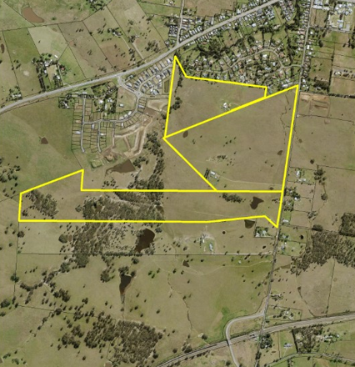

Figure 1

Located to the north is the New England Highway and the Main Northern Railway Line to the south, both of which are accessed via Station Lane.

Two 1st order creeks are located on the eastern side of the project area and converge to form a 2nd order roughly in the middle along the eastern border which is known as Greedy Creek that converges with a 3rd order unnamed creek in the north eastern section of the project area. Lochinvar Creek (3rd order) is located in and out of the project area along the western border of the project area. Refer to Figure 2 below.

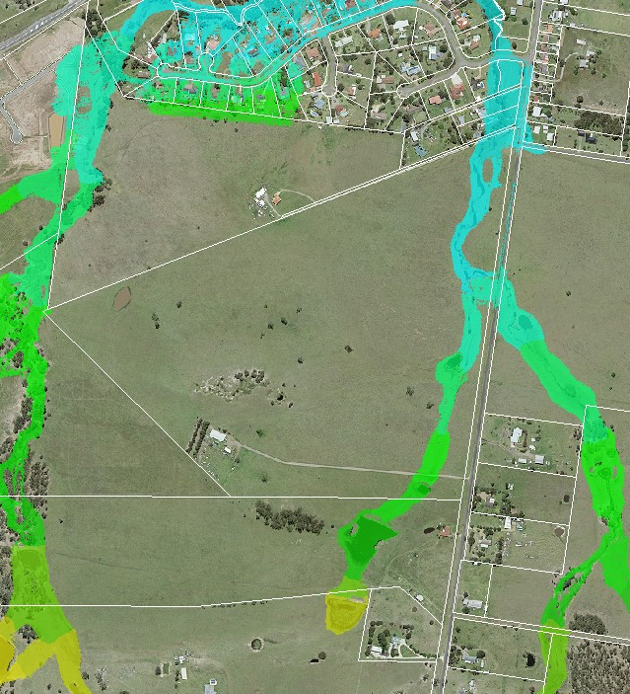

Figure 2

The development site is largely cleared of vegetation however pockets of remnant vegetation exist.

There is a reserved road (private) located within the northern portion of the site, and a 20m electrical easement traverses the south of the site. A watermain is located adjacent to the northern boundary.

Figure 3 below provides an outline of the development site which is to be improved through the construction of the residential subdivision. All associated works are to be contained within the area shaded grey and bounded in red.

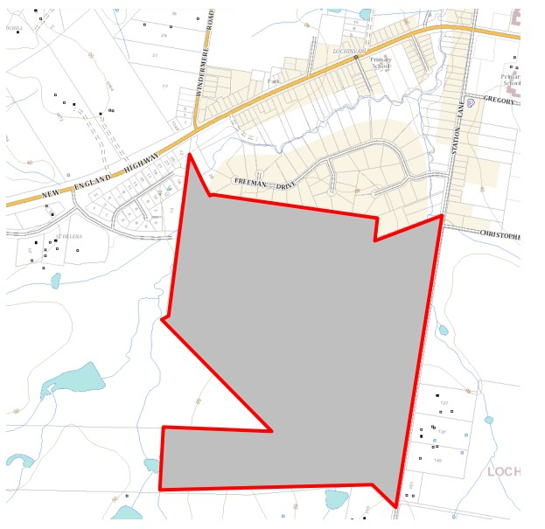

Figure 3

### Locality

The development site is located at Lochinvar to the west of Maitland, on the southern side of the New England Highway, within the LURA.

The LURA supports low density residential development at Lochinvar in line with the Hunter Regional Plan 2036, the Greater Newcastle Metropolitan Plan 2036 and the Maitland Local Strategic Planning Statement. Under the Lochinvar Urban Release Area plan in Part F of the DCP, the land is designated to be largely within Stage 2 and the remainder in Stage 3 of the Staging Plan (refer to Figure 9).

The locality consists of a mix of existing residential and new release residential development, cleared rural land and associated dwellings and structures.

Located to the north east are existing recreation fields, schools and small retail shops. The New England Highway provides access to Maitland to the east and Singleton to the west. To the south is the Main Northern Railway Line, with connection via the Lochinvar Train Station. Further to the south is the Hunter Expressway which is accessible by local roads.

## Proposal

Consent is sought for a Concept Development Application for residential subdivision incorporating 812 Torrens Title Lots (plus one residue) in Six Stages and Construction of Stage 1 for 203 Torrens Title Lots (plus 1 residue lot).

The development comprises the following:

* Concept Development Application (sec. 4.22 of EP&A Act 1979) for a six stage residential subdivision consisting of 812 residential allotments (sizes between 450m² to 1,116m²); 1 Residue Lot; Open space comprising 2 x active pocket parks and 2 x riparian corridors and drainage reserve; and associated civil works including delivery of roads, earthworks, drainage, connection to services.
* Detailed Development Application for first stage of subdivision – 203 Lots (sizes between 450m² - 804m²) and 1 residue lot; clearing of the land; planted buffer and open space link along the northern border of the site; associated civil works including delivery of roads, earthworks, drainage and connection to services; and works within riparian corridor comprising of the placement of fill and a culvert over 3rd order streams to facilitate a road.
* Demolition of all structures, including the removal of driveway and structures on Lot 3 as part of the Stage 1 works.
* Clearing of existing trees/vegetation except areas on the western side of Lochinvar Creek. The balance of the vegetation in the associated riparian area on the site will be removed to facilitate the construction of Terriere Drive. The vegetation removal around Lochinvar Creek will be part of the Stage 1 works.

The key development data is provided in table 1 below.

**Table 1: Key Development Data**

|  |  |
| --- | --- |
| **Control** | **Proposal** |
| Site area | Approximately 120 hectares |
| Clause 4.6 Request | No |
| Concept Stages | 6 (812 Lots @ 450m² to 1,116m²) |
| Detailed Stage | 1 (203 Lots @ 450m² - 804m²) |

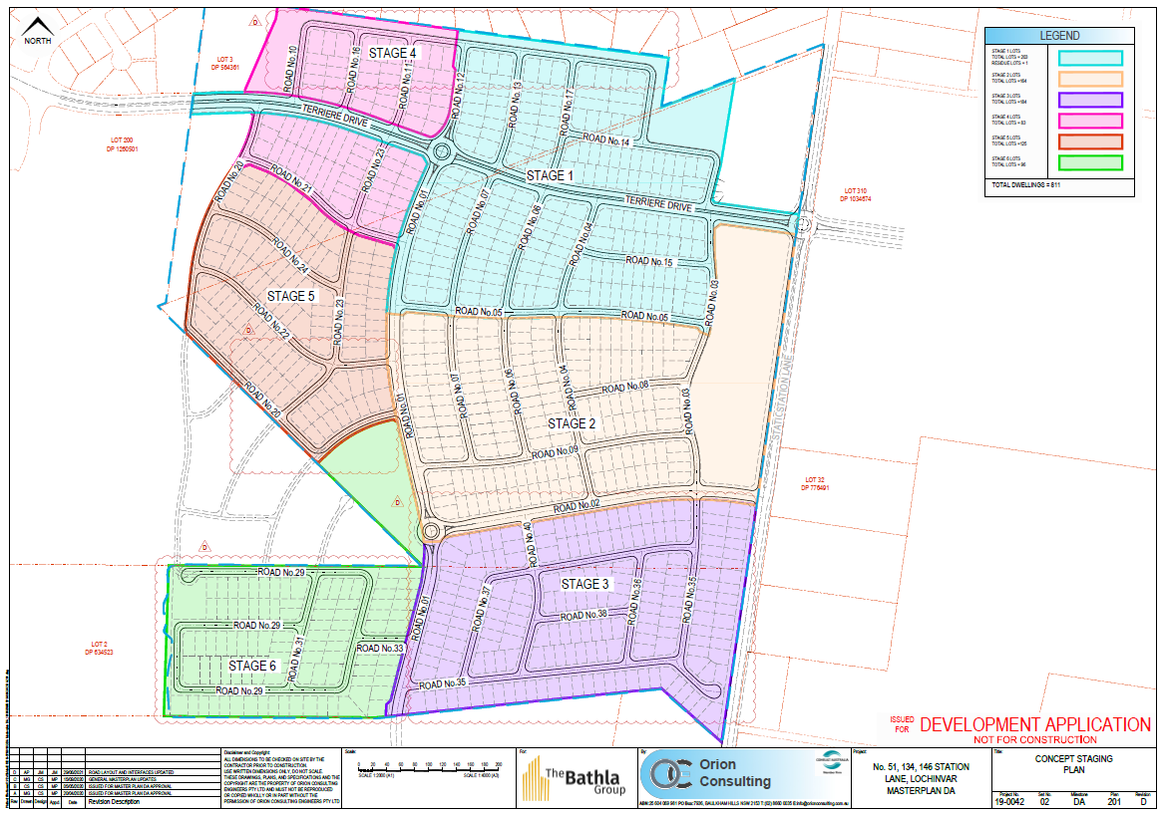

Figure 4

The following documentation has been provided in support of the amended application: Statement of Environmental Effects (Attachment A); Subdivision Plans (Attachment B); Civil Engineering Plans (Attachment C); Urban Design Report (Attachment D); Traffic Impact Assessment and Addendum (Attachment E); Contamination Investigation (Attachment F); Biodiversity/Ecological Report (Attachment G); Bushfire Protection Assessment (Attachment H); Aboriginal Heritage Due Diligence (Attachment I); Servicing Strategy (Attachment J); Letter of Offer* to Department of Planning – VPA Station Lane, Lochinvar (Attachment K).

*\* due to confidentiality reasons the Letter of Offer is made only available for the viewing of the Hunter & Central Coast Planning Panel and is not publicly available on the website.*

The DA is Integrated as a CAA under the Water Management Act 2000 (NSW) and a s100B authorisation under the Rural Fires Act 1997 (NSW) is required. The DA is Traffic Generating Development pursuant to SEPP (Infrastructure) and cl 45 applies under the same.

Note, the above information is derived from the amended application, however there are discrepancies with the figures as a count of the proposed lots from the plans provided identified in table 2 below:

Table 2 – Residential lot breakdown

|  |  |
| --- | --- |
| Total Residential Lots: | 848 |
| Stage 1: | 184 |
| Stage 2: | 164 |
| Stage 3: | 182 |
| Stage 4: | 74 |
| Stage 5: | 151 |
| Stage 6: | 92 |

### Chronology of DA

The development application was lodged on 16 December 2020. A chronology of the development application since lodgement is outlined in table 3 below.

**Table 3: Chronology of the DA**

|  |  |
| --- | --- |
| **Date** | **Event** |
| 16 December 2020 | Lodgement of DA |
| 1 February 2021 | Advertisement of the application |
| 28 January 2021 | DA referred to external agencies |
| 11 March 2021 | Panel briefing |
| 1 April 2021 | Request for Information from Council to applicant |
| 7 July 2021 | Amended plans lodged dated 29 June 2021 accepted by Council under Cl 55 of the Regulation on 28 July 2021. |
| 28 July 2021 | DA referred to external agencies |
| 29 July 2021 to 27 August 2021 | Re-advertisement of the application |
| 4 August 2021 | Panel briefing |
| 23 September 2021 | Change of Applicant |
| 4 November 2021 | Panel meeting for determination |

## Integrated Development Assessment

### Rural Fires Act 1997

#### Section 100B Fire Safety Authority

The application was lodged as Integrated development and the proposal was referred to NSW Rural Fire Service (NSW RFS). NSW RFS advised on 1 October 2021 additional information is required to address:

*The revised concept subdivision plan sites proposed lots in stage three (3) & stage six (6) directly adjacent to the grassland hazard to the south of the subject site where previously a perimeter road was proposed.*

*It is requested that additional information be provided demonstrating that potential building footprints on these lots directly adjoining the southern border of the site will not be exposed to radiant heat levels exceeding 29kW/m2 on each proposed lot in accordance with the requirements of Table 5.3a within Planning for Bush Fire Protection 2019.*

A copy of the NSW RFS correspondence is attached as Attachment L. A request for additional information to address the response by NSW RFS has not been issued to the applicant.

### Water Management Act 2000

#### Section 91 Controlled Activity Approval

The application was lodged as Integrated development and the proposal was referred to the NSW Natural Resource Access Regulator (NRAR). The application as lodged was assessed by NRAR with advice dated 11 February 2021 requiring further information to enable an assessment to be carried out.

NRAR provided a further request on 15 June 2021 identifying its concerns with the proposal having regard to providing General Terms of Approval (GTAs) under the Water Management Act 2000 in relation to a Controlled Activity Approval (Section 91). A copy of the NRAR correspondence is attached at Attachment M.

The amended application was referred to NRAR for comment, but no response has been received despite requests for an update on the assessment of the additional information.

## Section 4.15: Potential matters for consideration

Applicable State, Regional and Local Environmental Planning Instruments and Policies are detailed hereunder. Where not explicitly detailed, it is considered those instruments or policies are not relevant to the proposal.

## Section 4.15 (1) (a) (i) the provisions of any EPI’s

### State Environmental Planning Policy (State and Regional Development) 2011

The proposal is identified as regionally significant development under Part 4 Regionally significant developmentand Schedule 7 of the SEPP due to the capital investment value exceeding $30 million.

The Hunter and Central Coast Regional Planning Panel will be the consent authority for the application.

### State Environmental Planning Policy No. 55 – Remediation of Land

Under clause 7 of the SEPP a consent authority must not consent to the carrying out of any development on land unless:

1. it has considered whether the land is contaminated, and
2. if the land is contaminated, it is satisfied that the land is suitable in its contaminated state (or will be suitable after remediation) for the purpose for which the development is proposed to be carried out, and
3. if the land requires remediation to be made suitable for the purpose for which the development is proposed to be carried out, it is satisfied that the land will be remediated before the land is used for that purpose.

A Preliminary Site Investigation Assessment (PSIA) was provided with the amended application. The report investigated the likelihood of ground contamination on the site from previous land uses and determined that Arsenic concentrations above the site assessment criteria were present in some samples. The report outlines the site can be made suitable for the development subject to the implementation of a Remediation Action Plan.

The PSIA has been reviewed and concluded the land is suitable for low-medium density residential use in terms of soil contamination. Further review is required in terms of recommended conditions in the form of a Remedial Action Plan.

### State Environmental Planning Policy (Infrastructure) 2007

#### Part 3, Division 5, Subdivision 2 Development likely to affect an electricity transmission or distribution network

In accordance with clause 45(2) of the SEPP, the application was referred to Ausgrid for comment. Ausgrid raised no objection to the development, subject to minimum clearances to electrical infrastructure being achieved. A copy of Ausgrid’s correspondence is attached at Attachment N.

#### Part 3, Division 17, Subdivision 2 Development in or adjacent to road corridors and road reservations

Under Section 104 Traffic Generating Development and Schedule 3 Traffic generating-development to be referred to Transport for NSW, as the development proposes the subdivision of land of more than 200 lots the development triggers the clause and the matter was referred for review.

Transport for NSW (TfNSW) provided a response to Council dated 6 October 2021 (refer to Attachment O) advising it has reviewed the amended application information and provided the following comments:

* The subject development is located within the LURA, with the ultimate traffic management scheme identified in Map 3 Road & Traffic Facilities in Council’s Lochinvar Section 94 Contributions Plan 2014.
* Under DA/2019/958, the Terriere Drive / New England Highway intersection was upgraded to a seagull intersection. This was an interim treatment in the LURA and determined to sufficiently operate for up to 190 new allotments. This apportionment was entirely taken up by this subdivision application.
* Constraints in the orderly development of the LURA are acknowledged such as the limited connections available through the Southern Ring Road and no signalised intersection at Terriere Drive and the New England Highway.
* Cumulative development within the LURA has identified traffic movements in excess of that initially projected at the intersection of Station Lane and the New England Highway. Until such time that orderly development and / or the ultimate development scenario eventuates, this traffic, safety and efficiency impact appears to be an interim development scenario.
* TfNSW supports a requirement for a further Traffic Impact Assessment (TIA), should Council consider it appropriate, to understand the cumulative impacts and any interim solutions required to support activation of the LURA. Noting however, Council needs to determine the appropriate planning mechanisms / funding arrangements to manage out of sequence development.
* TfNSW recommends within the subject TIA to determine the impact of the interim development scenario on the intersection of:
* Terriere Drive and the New England Highway
* Station Lane and the New England Highway and U-turn facility currently under construction.

This needs to include a cumulative assessment of all other active and proposed developments potentially accessing this intersection, as well as their estimated time of delivery / release and dwelling construction.

Accordingly, the application is not supported by TfNSW as the applicant has not demonstrated the existing road network, subject to upgrades, is able to accommodate the increased traffic generated by the proposed subdivision.

#### Part 3, Division 20 Stormwater management systems

Section 111A development permitted with consent, identifies that development for the purpose of a stormwater management system may be carried out by any person on any land.

The drainage works associated with the development are located within the R1 and RU2 zones. In accordance with the SEPP, these works are permitted in this zone with consent (refer to comment under clause 7.3 of the MLEP2011).

### State Environmental Planning Policy (Koala Habitat Protection) 2020

The applicant provided a Biodiversity Development Assessment Report (dated 2020) which advised the SEPP (2019) applies to the City of Maitland Local Government Area. The application identifies the development site as potential Koala Habitat, noting however it is a highly modified environment.

The report concludes that with ‘…the absence of records of Koala in the last 18 years on site or in the locality mean that the Subject Site is not considered as Core Koala Habitat under the relevant SEPP and as such, no further provisions of the policy apply’. The application based this information on a desktop search in the NSW BioNet Atlas of threatened species from an area of 10km by 10km around the development site.

Having regard to the impacts of the proposed development, the residential zoned land is highly modified, with small isolated pockets of remnant vegetation (refer to Figures 1 & 2). The development proposes to clear the residential zoned land of the remnant vegetation, with remnant vegetation on the rural zoned portion of the site to be retained.

Whilst the outcome of the assessment of Koala Habitat is unlikely to change, a revised assessment is required to address current legislation (SEPP 2020) to ensure the development application is compliant.

Note, State Environmental Planning Policy (Koala Habitat Protection) 2021 does not apply as the City of Maitland Local Government Area is outside of the Sydney Metropolitan Area and the Central Coast.

### Maitland Local Environmental Plan 2011

#### Part 2 – Permitted or prohibited development

The development is for the subdivision of land, including the creation of 812 residential lots within the R1 zone, 1 residue lot of land in the RU2 zone. Associated with the residential subdivision will be ancillary works including land clearing, demolition works, earthworks, civil works, drainage, connection to services, and landscaping including works in the riparian zone.

The development site is zoned R1 Residential and RU2 Rural Landscape under the MLEP2011 (refer to Figure 5). Subdivision of land in the R1 and RU2 zones is permissible with consent subject to compliance with Clause 4.1 of the MLEP2011. As identified in Figure 3, all works relating to the residential component of the proposed subdivision are being undertaken within the R1 zone.

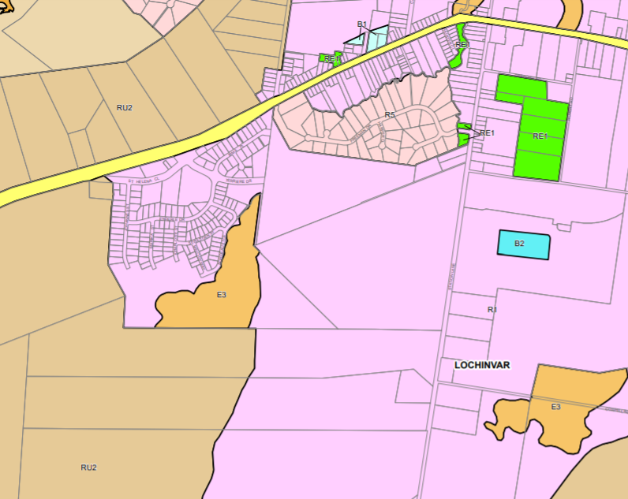

Figure 5

The objectives of the R1 zone are:

* To provide for the housing needs of the community.
* To provide for a variety of housing types and densities.
* To enable other land uses that provide facilities or services to meet the day to day needs of residents.

The objectives of the RU2 zone are:

* To encourage sustainable primary industry production by maintaining and enhancing the natural resource base.
* To maintain the rural landscape character of the land.
* To provide for a range of compatible land uses, including extensive agriculture.
* To provide for a range of non-agricultural uses where infrastructure is adequate to support the uses and conflict between different land uses is minimised.

The proposed development does not meet the zone objectives as it:

* does not address the housing needs of the community in terms of providing diversity of housing choice;
* lacks variety of housing types and densities with 90% of the lots having an area of 450 to 650m²;
* does not maintain the rural landscape character of the land through the protection of water courses and riparian zones.

#### Clause 4.1 Minimum subdivision lot size

The development site is zoned R1 Residential and RU2 Rural Landscape. The minimum lot size map (refer to Figure 6) identifies the land as part G (R1) and AB3 (G).

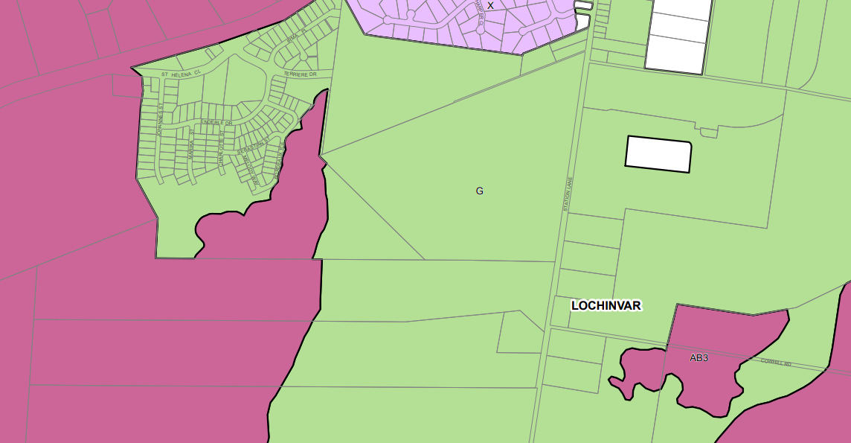

Figure 6

G: 450m²

All of the proposed lots within the R1 zone meet the minimum lot size under this clause of the MLEP2011.

AB3: 40 hectares

The residue area of Lot 2 in DP634523, no. 146 Station Lane, Lochinvar has not been nominated. As the existing area under the Deposited Plan is 41.09 hectares, with the RU2 zoning taking up approximately half of the lot area, it is clear the residue is below the minimum lot size.

The proposed subdivision does not comply with Clause 4.1 of the MLEP2011 in relation to the lot size for the land zoned RU2. The proposed subdivision seeks to subdivide the R1 land from the RU2 land. The area of the residue RU2 land has not been nominated in any of the documentation provided with the application, noting however Lot 2 has an area of 41.09 hectares it is estimated at approximately 25 hectares being below the minimum lot size for land zoned RU2. A clause 4.6 exception to the development standard has not been provided for the proposed under sized lot. Nor does the development comply with Clause 4.2C as detailed below.

#### Clause 4.2C Minimum subdivision lot sizes for certain split zones

The development site contains Lot 2 in DP634523, no. 146 Station Lane, Lochinvar.

This site is mapped as having a split zoning under the MLEP2011, incorporating both the R1 Residential and the RU2 Rural Landscape zonings (refer to Figure 7).

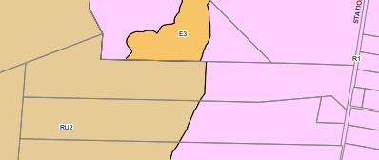

Lot 2 – MLEP2011 Sheet LZN_002A

Figure 7

The proposed subdivision seeks to subdivide the R1 land from the RU2 land as opposed to retaining the residue with a compliant lot in the R1 zone.

Refer to comment under Clause 4.1 regarding minimum lot sizes.

#### Clause 4.6 Exceptions to development standards

Not Applicable – no exception to a development standard has been lodged with the development application.

#### Clause 5.10 Heritage conservation

The development site is not listed as a heritage item nor being contained within a heritage conservation area under Schedule 5 of the MLEP2011. An inspection of the development site did not identify any buildings, structures or works warranting further assessment for determining heritage significance.

Sub-clause (8) states the consent authority must, before granting consent:

(a) consider the effect of the proposed development on the heritage significance of the place and any Aboriginal object known or reasonably likely to be located at the place by means of an adequate investigation and assessment (which may involve consideration of a heritage impact statement), and

(b) notify the local Aboriginal communities, in writing or in such other manner as may be appropriate, about the application and take into consideration any response received within 28 days after the notice is sent.

A search of the Aboriginal Heritage Information Management System database with regard to the development site and a 200m buffer identified three (3) listed sites (refer to Attachment P).

In a request for information dated 9 April 2021, the applicant was requested to provide an Aboriginal Cultural Heritage Assessment (ACHA).

The applicant provided an Aboriginal Heritage Due Diligence Assessment, dated 23 April 2020, in support of the application. On 30 June 2021 the applicant advised a report is underway and will be submitted in July. In the amended application’s Statement of Environmental Effects, the Due Diligence report was referenced to respond to Aboriginal Heritage Impact.

To date no ACHA has been provided.

Consequently, an assessment of the effect of the proposed development on Aboriginal Heritage is not able to be completed. In particular, the applicant has not undertaken consultation with the Aboriginal Community.

#### Clause 6.1 Arrangements for designated State public infrastructure

Satisfactory arrangements for the provision of designated State public infrastructure for the subdivision of land in the Lochinvar urban release area have not been resolved for this development application.

The Department of Planning, Infrastructure and Environment (DPIE) advised on 9 August 2021 it has been liaising with the applicant regarding a draft Voluntary Planning Agreement in terms of satisfying the requirements of Clause 6.1 for the proposed subdivision. The DPIE advised the draft VPA (and satisfaction of the clause) is yet to be finalised.

#### Clause 6.2 Public utility infrastructure

The proposed subdivision can be satisfactorily serviced by public utility infrastructure as per the following advice.

The application plans were stamped by Hunter Water Corporation advising water is available for connection whilst sewer connection is not available. A Preliminary Water and Sewer Servicing Advice lodged with the application by an accredited supplier identified a trunk sewer line is planned along Station Lane which can service this development, subject to all lots draining under gravity into the new trunk sewer scheme.

In terms of electricity, Ausgrid has not raised any issues with the connection of the development to its grid subject to a connection application being lodged at an appropriate time.

#### Clause 6.3 Development control plan

The DCP 2011 incorporates section F.9 – Lochinvar Urban Release Area under Part F – Urban Release Areas, which provides controls for the Lochinvar Urban Release Area as mapped by the MLEP2011.

The consent authority is able to consider the merits of the development application against the controls of the DCP, and can determine the development application by either granting or refusing consent.

#### Clause 7.1 Acid sulfate soils

The site is mapped as being affected by Class 5 acid sulfate soils (ASS).

As there is no certainty over the design of the development due to inadequate information, an assessment of the impacts on ASS cannot be completed.

#### Clause 7.2 Earthworks

The earthworks are ancillary to the proposed residential subdivision refer to assessment comment under the DCP.

The application identifies bulk earthworks (cut and fill) to the majority of the site, which has not been minimised as required in the request for information dated 9 April 2021. The application has identified the import of fill of approximately 2,234m².

The extent of earthworks is not supported as it has not been demonstrated the outcome will not have a detrimental impact on environmental functions and processes (drainage, flooding).

#### Clause 7.3 Flood planning

The development site is not mapped as a Flood Planning Area (FPA), however land downstream is mapped as a FPA.

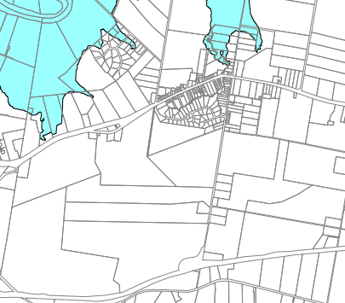

Figure 8

Sub-clause (3) states the development consent must not be granted to development on land to which this clause applies unless the consent authority is satisfied the development:

(a) is compatible with the flood hazard of the land, and

(b) is not likely to significantly adversely affect flood behaviour resulting in detrimental increases in the potential flood affectation of other development or properties, and

(c) incorporates appropriate measures to manage risk to life from flood, and

(d) is not likely to significantly adversely affect the environment or cause avoidable erosion, siltation, destruction of riparian vegetation or a reduction in the stability of river banks or watercourses, and

(e) is not likely to result in unsustainable social and economic costs to the community as a consequence of flooding.

The applicant has not provided a comprehensive flood study and stormwater management plan and report to the satisfaction of Council in response to Council’s request for information (1 April 2021). There is no further information that supports the application or gives understanding with regard to:

* minimum floor levels for dwellings to be constructed within the development;
* floodway’s flowing through the site from the south, with the proposal showing house lots in this floodway;
* onsite detention, major and minor system outflows. Whilst the application shows a small temporary detention basin within the existing floodway (which is not supported) the applicant has ignored the basic and regular requirements of Council’s Manual of Engineering Standards which is to mimic the natural runoff flows for the other events. The application is solely focussed on downstream flooding in isolation of all other impacts and in doing this they seek to allow un-detained flows ahead of the catchment flood peak, whilst downstream flooding is extremely important to consider and alleviate it is not the only important stormwater metric to achieve. The applicant has not provided a satisfactory argument as to why Council’s standards are not being followed.
* The application shows a temporary swale downstream of the farm basin but not any permanent arrangements in maintaining the existing floodway, which is not supported.
* Dam safety issues have not been addressed in relation to a dam located to the south of the development site on separately owned land.

Note: the savings provisions under Clause 1.8A of the MLEP2011 state if a development application has been made but not determined before the commencement of the plan then the application must be determined as if the plan had not commenced. In this regard, the development application was lodged prior to the repeal of Clause 7.3 and the introduction of Clauses 5.21 Flood planning and 5.22 Special flood considerations.

## Section 4.15 (1) (a) (ii) the provisions of any draft EPI

No issues are identified relating to the following Draft State Environmental Planning Policies:

Draft Amendments to Codes SEPP

Draft Environment SEPP

Draft Design & Place SEPP

Draft Diverse and Affordable Housing SEPP

Draft Remediation of Land SEPP

Draft Repeal of Operational SEPPs

There are no applicable Draft EPIs with regard to the MLEP2011.

Note: standard clauses 5.21 Flood planning and 5.22 Special flood considerations have been added to the MLEP2011 since lodgement of the development application. These clauses replace repealed clause 7.3 Flood planning. Under the provisions of clause 1.8A of the MLEP2011, clauses 5.21 and 5.22 are to be treated as provisions of a draft EPI and the matter is to be determined against clause 7.3

As a comprehensive flood study and stormwater management plan and report to the satisfaction of Council has not been provided with the application a complete assessment against the draft provisions of clauses 5.21 and 5.22 has not been undertaken.

## Section 4.15 (1) (a) (iii) DCP’s

### Maitland City Council Development Control Plan 2011

**Part F – Urban Release Areas**

Staging Plan

The Lochinvar Urban Release Area Staging Plan (refer to Figure 9) identifies the development site as being within Stages 2 and 3.

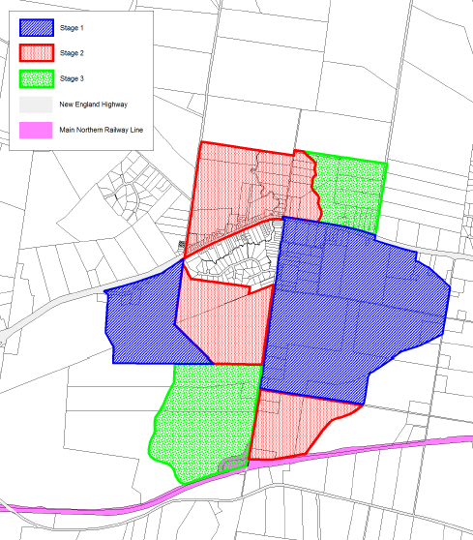

Development site

Figure 9

The application has not been able to demonstrate to the satisfaction of Council and other stakeholders (TfNSW), of the suitability of the development occurring out of sequence. The key concerns with the development proceeding out of sequence relate to the provision of infrastructure, serviceability, and the imposts on Council for providing works under the contributions plan out of sequence whereby contributions received are not at the expected level.

The applicant in the SoEE for the amended application offered to negotiate with Council regarding the provision of works in kind for the required infrastructure but no details were provided.

Transport and Movement

The proposed development is subject to the Proposed Road Hierarchy for the Lochinvar Urban Release Area, an excerpt of which is provided below as Figure 10. This development is subject to the Southern Link Road (divided carriageway), primary distributor roads and is to contain a Roundabout and directly adjoin a Traffic Control Signalised intersection.

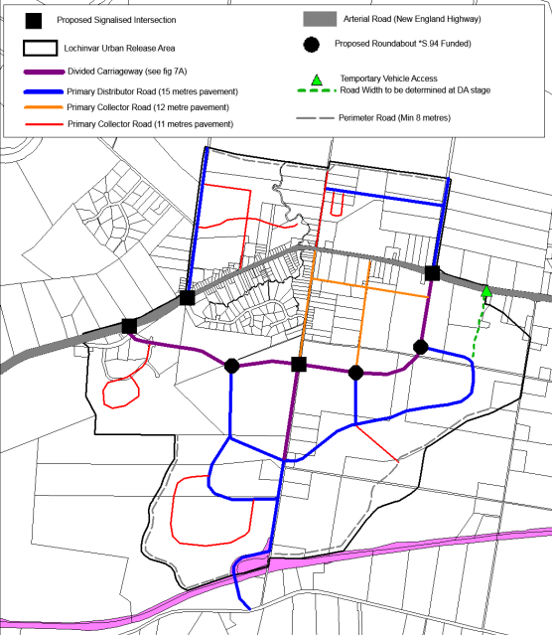

Figure 10

The development application seeks to subdivide land located partly in Stage 2 (51 Station Lane and 134 Station Lane) and partly in Stage 3 (146 Station Lane). The proposal for stage 1 of the concept application seeks to connect to the New England Highway via Terriere Drive to the west, and under subsequent stages connect to Station Lane to the east.

These connections to Station Lane, particularly the intersection of Terriere Drive, are being provided in a sequence suiting the development and not the public benefit, ie. the extension of Terriere drive is to be constructed for the full length but is proposed to stop short of the intersection with Station Lane.

In addition to the works occurring out of sequence, the development application seeks to modify the layout/alignment of the road system and modify the Traffic Control Signalised intersection of Terriere Drive and Station Lane to a roundabout. Such matters have not been resolved to the satisfaction of Council.

The Traffic report has not addressed the traffic impacts created by the development for each stage and not addressed at what stage each of the key intersections and roads require upgrade/reconstruction or the what the extent of those upgrades entail.

With regard to on-street parking, footpaths, pedestrian linkages and public transport mentioned, the applicant has provided limited detail. There does not appear to be any analysis on regular matters such as school kids walking and cycling safely to and from school sites, residents walking and cycling to and from commercial centres, recreation areas and other places of interest and safely negotiating/crossing Station Lane and Greedy Creek to the commercial centre and other facilities within the URA.

Refer to the comments by TfNSW under the SEPP (Infrastructure) section of this report for comments regarding the development being designated as a Traffic Generating Development under the SEPP (Infrastructure 2007) and connections to the state/main road network (New England Highway).

Landscaping

A landscape plan has not been submitted with the amended application as requested, therefore the development application cannot be assessed against the requirements of DCP.

Passive and Active Recreation Areas

Without resolution of broader issues in relation to access, drainage and flooding, there is no certainty over the development and as such a final assessment against the DCP requirements has not been undertaken.

Considering the extent of earthworks and clearing, the proposed development is inconsistent with the intent of retaining remnant vegetation within open space.

Stormwater and Water Quality Management

Refer to comment under clause 7.3 of the MLEP2011.

Amelioration of Natural and Environmental Hazards

The amended application has not satisfactorily addressed flooding and bushfire hazards, refer to comments in this report under clause 7.3 of the MLEP2011 and the Rural Fires Act 1997 respectively. For matters relating to contamination, refer to comments under SEPP55.

Aboriginal & European Heritage

Refer to comment under clause 5.10(8) of the MLEP2011.

Provision of Public Services & Facilities

Without resolution of broader issues in relation to access, drainage and flooding, there is no certainty over the development and as such a final assessment against the DCP requirements for access to public facilities and services has not been undertaken.

## Section 4.15 (1) (a) (iv) any matters prescribed by the regulations

**Division 3A Special provisions relating to concept development applications**

Section 70A under Division 3A sets out what Information to be included in concept development application. It states that despite clause 50(1)(b) and (c), the information required to be provided in a concept development application in respect of the various stages of the development may, with the approval of the consent authority, be deferred to a subsequent development application.

The applicant has not been advised of any information which can be deferred to a subsequent development application.

## Section 4.15 (1) (b) the likely impacts of the development

#### The likely impacts of the development cannot be determined due to the incomplete and inconsistent information provided with the development application.

## Section 4.15 (1) (c) the suitability of the site for development

#### Does the proposal fit the locality?

The documentation provided with the development application has failed to demonstrate the proposal is fit for the locality.

#### Are the site attributes conducive to development?

The documentation provided with the development application has failed to demonstrate the site attributes are conducive to the development.

## Section 4.15 (1) (d) any submissions made in accordance with this Act or the Regulations?

The development application was advertised and notified from 1 February 2021 to 2 March 2021. Eight submissions were received from this advertisement/notification period, incorporating one submission in support and seven submissions as objections. A further submission was received outside the advertisement/notification period, as an objection.

The amended application was advertised and notified from 29 July 2021 to 27 August 2021. One submission was received from the advertisement/notification period for the amended application, being an objection to the development.

In total ten submissions were received from nine parties, refer to Attachment Q for copies of the submissions. The issues raised in these submissions included the following:

* Energy efficient design of dwellings, including solar energy,
* Waste Management
* Traffic impacts and provision of infrastructure
* Flooding/Drainage
* Stormwater management
* Environmental impacts
* Access to retail services and public transport
* Provision of recreation land and related facilities
* Upgrade of infrastructure (services)
* Loss of native vegetation and fauna
* Impacts on rural outlook
* Landscaping of creek lines and for visual separation

An Information Report was provided to the elected Council at its meeting of 12 October 2021 detailing the progress of the application. It was resolved that the application be deferred to allow for Council officers to have ongoing discussions with the new Applicant and Owner. A copy of the Council resolution is attached as Attachment R.

## Section 4.15 (1) (e) the public interest

The development is not considered to achieve balanced and orderly outcomes and is therefore not in the public interest.

The development application is incomplete and presents inconsistent information with regard to the proposed development. A full assessment of the proposed development is not possible with the information provided, nor is there certainty over the design outcomes noting broader issues such as access, drainage and flooding remain unresolved.

The development application has not addressed the ownership of the reserved road (private road) in the northern portion of the site over which works are proposed, and therefore is not a competent application under clause 49(1)(b) of the Environmental Planning & Assessment Regulations 2000.

The development does not meet the zone objectives and has failed to demonstrate compliance with relevant controls in the MLEP2011 and the DCP.

The development has not obtained the General Terms of Approval from the NSW RFS for the Section 100B of the Rural Fires Act 1997 and the NRAR for Section 91 of the Water Management Act 2000.

The development has also not satisfied the requirements of TfNSW with regard to it being a traffic generating development under the SEPP (Infrastructure) 2007.

The development has failed to demonstrated no significant environmental impacts will arise now or in the future, and is therefore not in the public interest.

#### Section 7.11 Contribution towards provision or improvement of amenities or services

The development is subject to development contributions under the Lochinvar Section 7.11 Contributions Plan 2014. To be applied under the Contributions Plan are the following key considerations of connections/integration:

* L7 (Local Neighbourhood Playground Northern catchment central precinct, size 0.5 hectares).
* L38 (stormwater basin) in Lot 2, adjoins road 29.
* L35 Off road trail – adjacent to the site
* Playground co-located L8 L17 6.5ha Sportsground on adjacent site to the south

Applicable contributions can be levied upon the development however until there is certainty over the proposal in terms of lots, a final calculation cannot be determined.

Note, presently the development application does not include details of any works in kind nor has a Planning Agreement been offered in relation to the provision of infrastructure as listed in the Contributions Plan.

**Conclusion**

An assessment of the application has been undertaken against Section 4.15(1) of the *Environmental Planning and Assessment Act, 1979 as amended*. Based on the balance of the matters considered, the development application cannot be supported, and it is recommended for refusal for the following reasons:

* the development does not meet the requirements of State Environmental Planning Policy (Infrastructure) 2007;
* the development has not addressed the requirements of State Environmental Planning Policy (Koala Habitat Protection) 2020;
* the development does not comply with the provisions of the Maitland Local Environmental Plan 2011;
* the development does not comply with various controls contained in Part F of the Maitland Development Control Plan 2011;
* consideration has been given to draft environmental planning instruments which have been the subject of public consultation;
* considering the likely impacts of the development on the natural and built environments, the development does not provide balanced and appropriate outcomes;
* the suitability of the site for the development, including characteristics and constraints of the land have been considered and it was found the land is not suitable for the development as proposed;
* the development has not addressed the requirements of Integrated Development Approval bodies having regard to the Rural Fires Act, 1997, and the Water Management Act, 2000;
* the development has not adequately addressed matters of public interest in relation to social, economic and environmental outcomes;
* Owner’s consent for the reserved road (private) over which works are proposed have not been provided.

Based on the balance of the matters considered, the development application cannot be supported, and it is recommended for refusal.

| Staff endorsement |
| --- |
| The staff responsible for the preparation of the report, recommendation, or advice to any person with delegated authority to deal with the application has no pecuniary interest to disclose in respect of the application.  The staff responsible authorised to determine the application have no pecuniary interest to disclose in respect of the application.  Signed:  Brian Gibson  Principal Planner  Planning and Environment |
| Senior endorsement |
| The staff responsible for the preparation of the report, recommendation, or advice to any person with delegated authority to deal with the application has no pecuniary interest to disclose in respect of the application.  The staff responsible authorised to determine the application have no pecuniary interest to disclose in respect of the application.  Signed:  Kristy Cousins  Coordinator Planning and Development  Planning and Environment |